**-- 1) Entire Table**

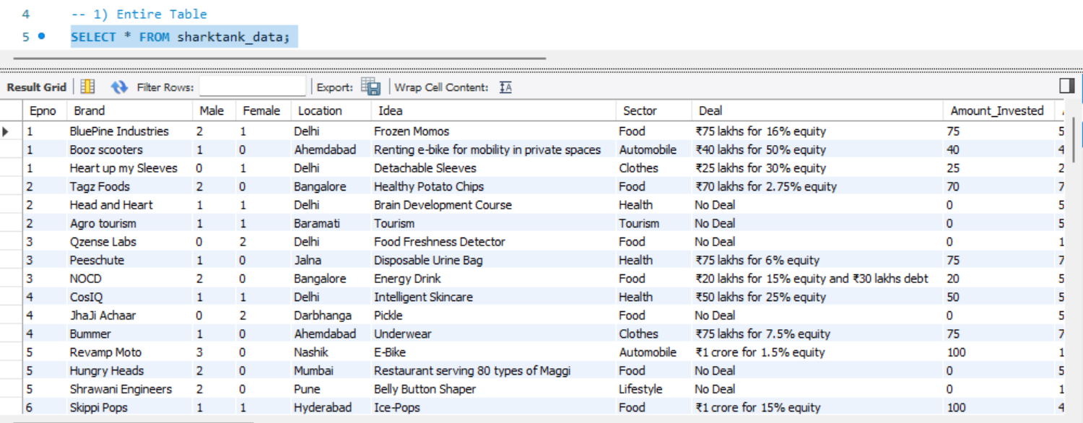

**-- 2) Total Episode**

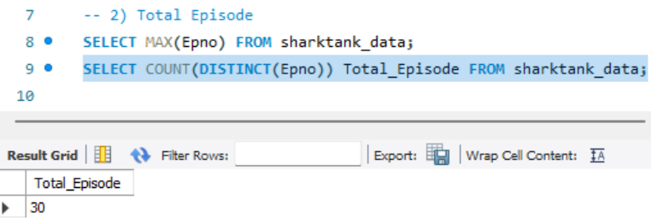

-**- 3) Total Pitches**

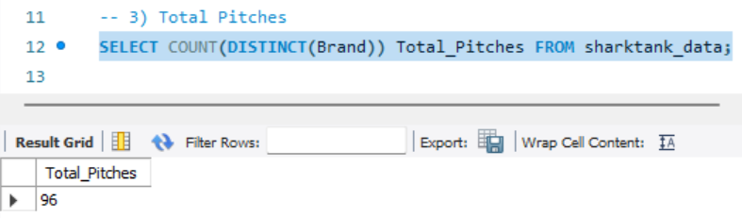

**-- 4) Pitches which got funding**

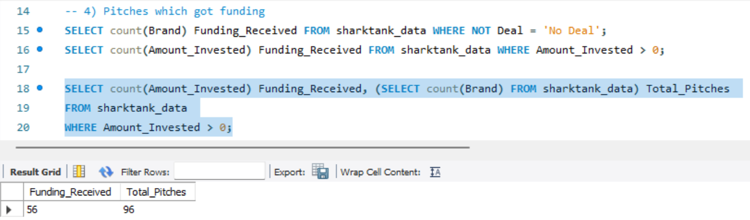

**-- 5) Successful investment count**

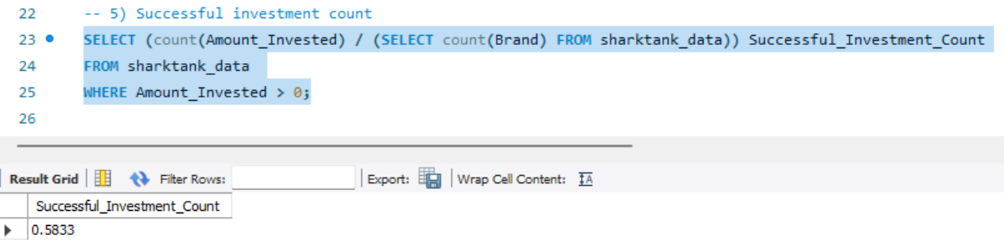

**-- 6) Total Male pitchers**

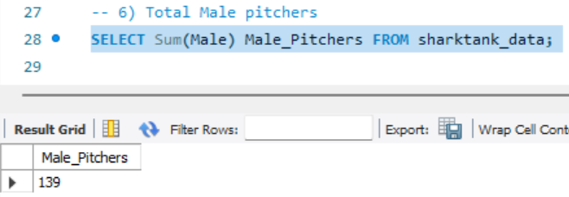

**-- 7) Total Female pitchers**

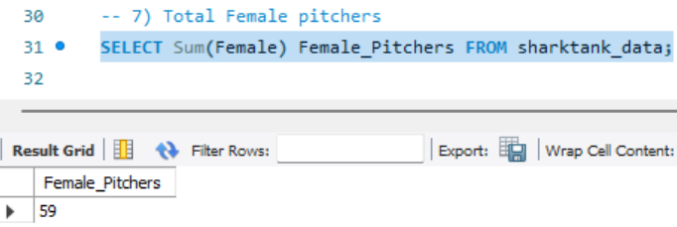

**-- 8) Gender Ratio of Pitchers**

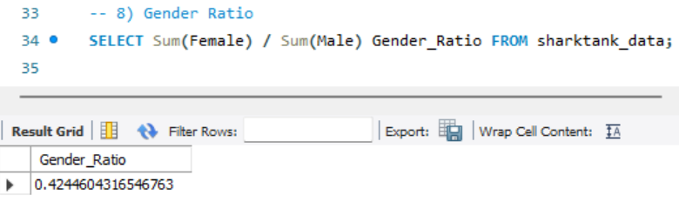

**-- 9) Total Invested Amount**

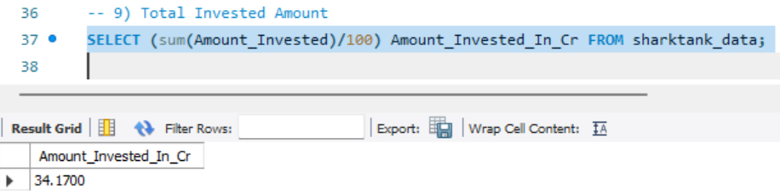

**-- 10) Average Equity Taken (Where deals were made)**

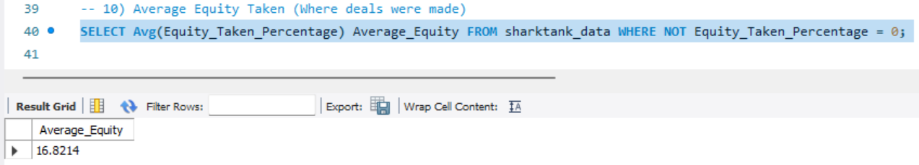

**-- 11) Highest Amount Invested**

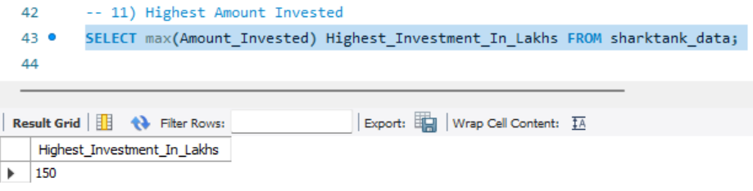

**-- 12) Highest Equity Taken**

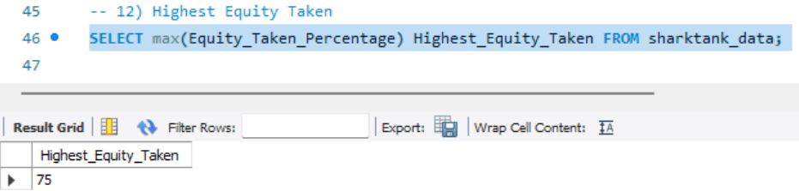

**-- 13) Pitches with atleast 1 Female contestant**

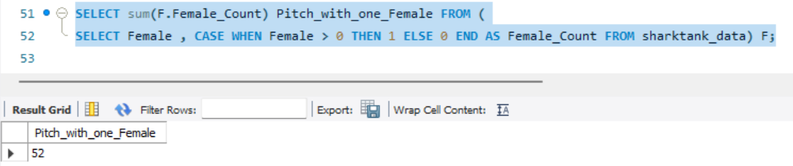

**-- 14) Pitches converted having one female contestant**

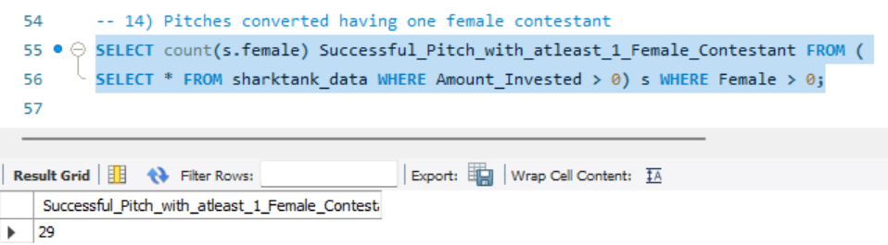

**-- 15) AVG Team members**

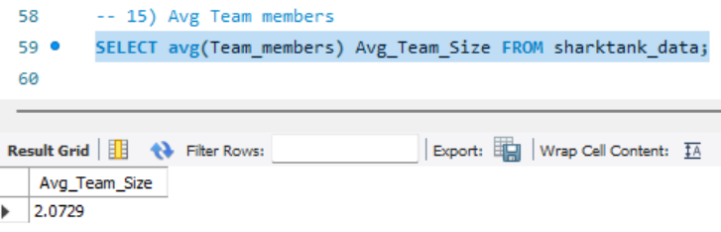

**-- 16) Avg Amount invested per deal (only where funding received)**

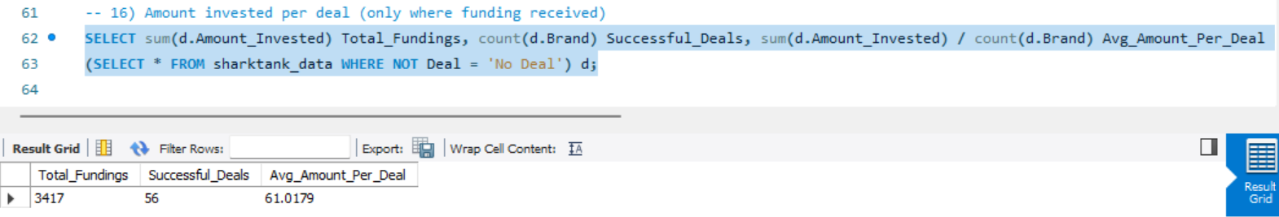

**-- 17) Average Age group of contestants**

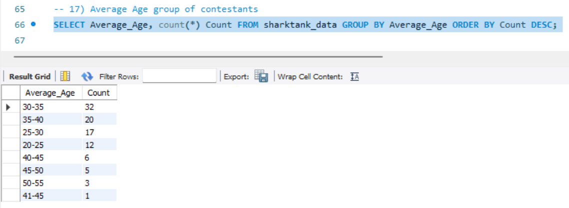

**-- 18) Location-wise split of pitches**

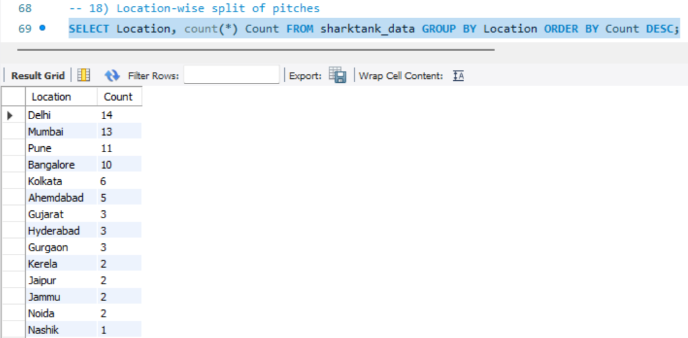

**-- 19) Sector-wise split of pitches**

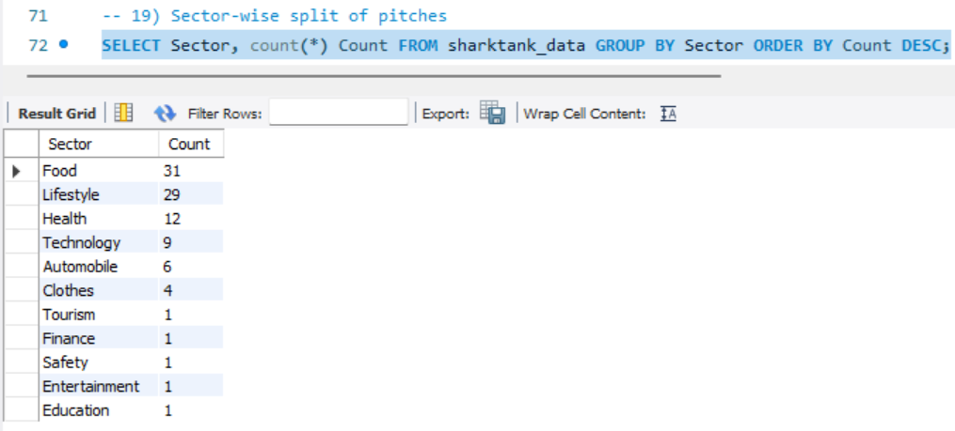

**-- 20) Standalone Deals**

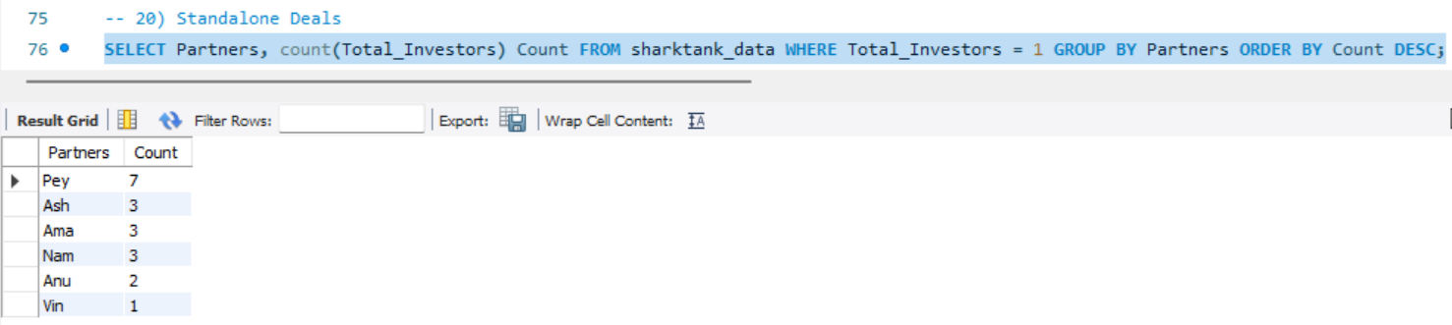

**-- 21) Partner Deals**

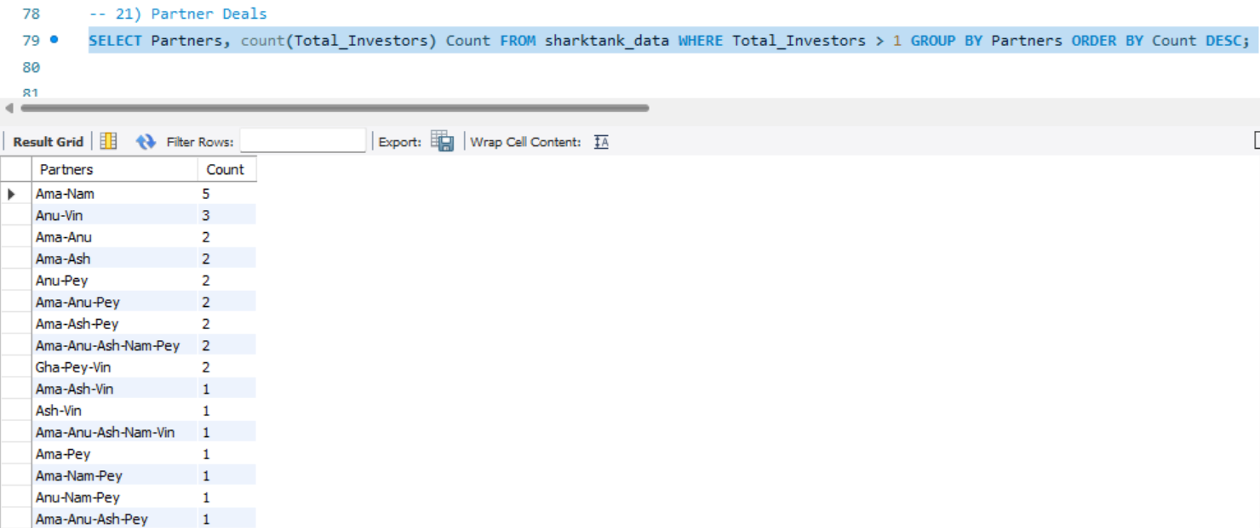

**-- 22) Statistics of a Shark**

**-- Ashneer**

**-- Query 1 – On how many episodes was Ashneer present?  
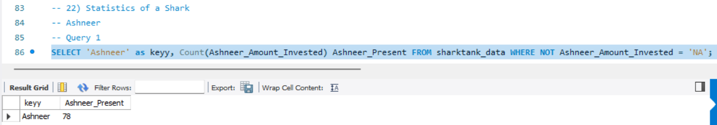**

**-- Query 2 – In how many Pitches did Ashneer invested?  
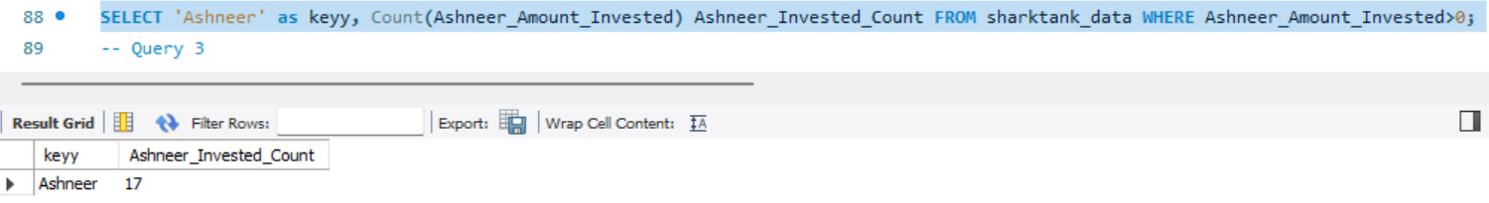**

**-- Query 3 – Total & Average Amount invested by Ashneer**

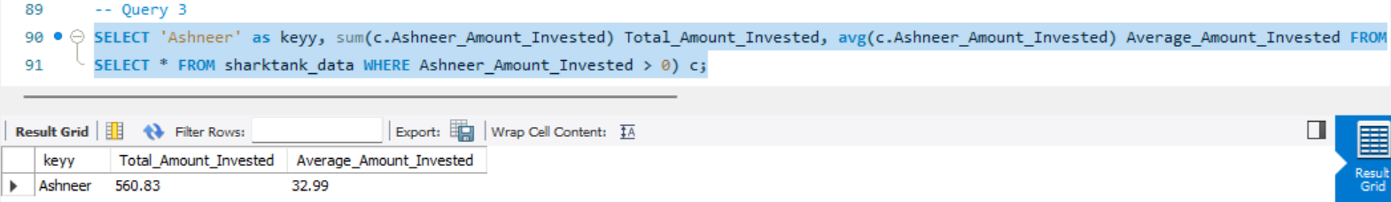

**-- Main Query (Ashneer) – (Using Inner Join, joined all 3 above queries)**

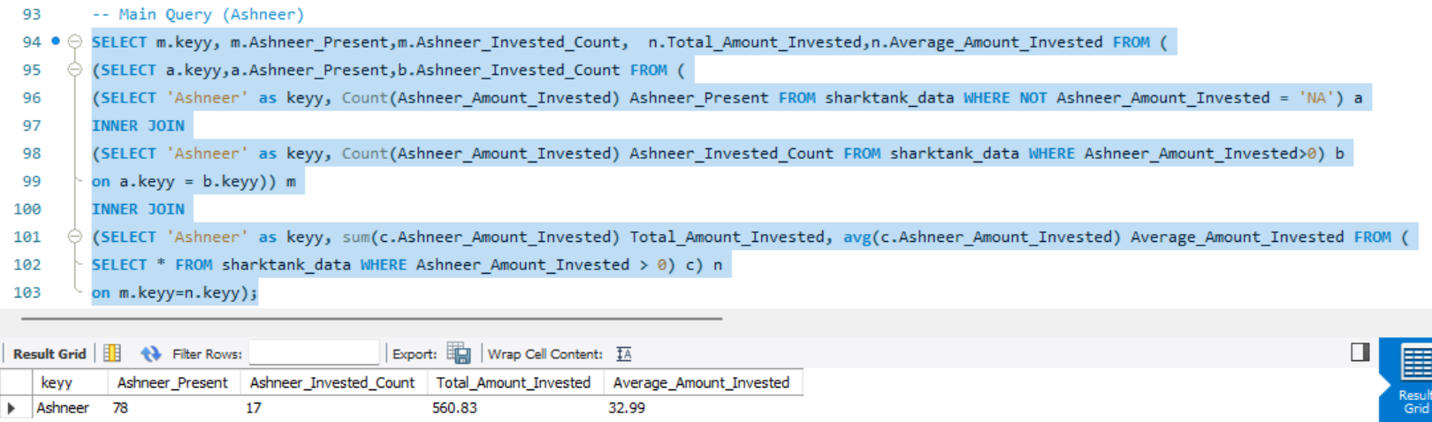

**-- (Anupam)**

**-- Query 1 - On how many episodes was Anupam present?**

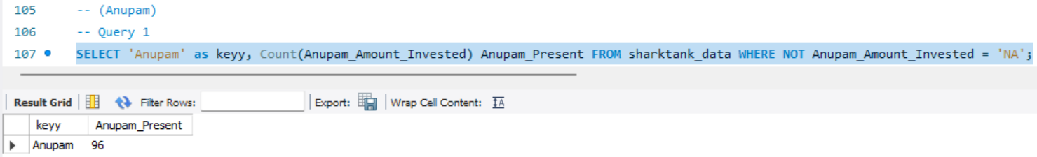

**-- Query 2 - In how many Pitches did Anupam invested?**

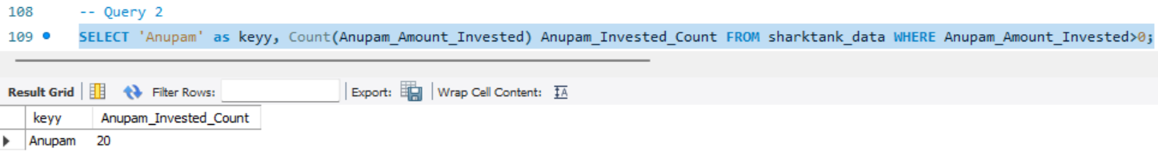

**-- Query 3 – Total & Average Amount invested by Anupam**

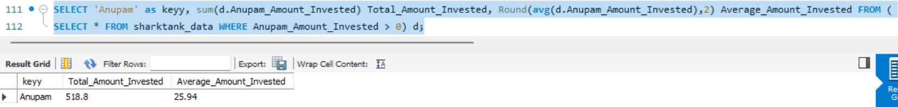

**-- Main Query (Anupam) – Joining all 3 above queries**

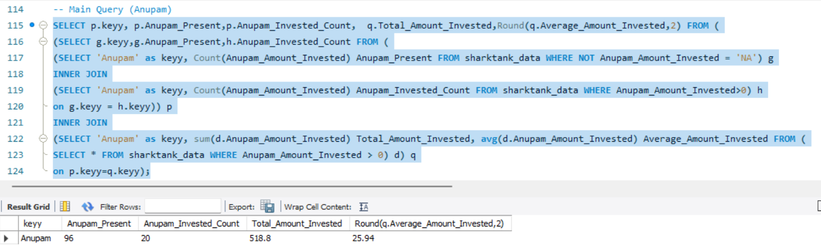

**-- 23) Anupam and Ashneer statistics combined – (Using Union and Join concept, appended the stats)**

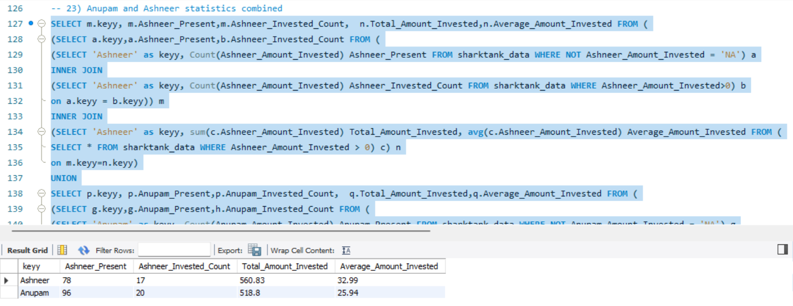

**-- 24) Sector-wise startup with highest investment – (Used RANK function to get the brand with highest investment in the each sector)**

